Case Report:
Conservative Management of Radicular cyst in deciduous molar: A case report
¹Dr.Benzeer Shaikh, ²Dr.Shantanu Choudhari, ³Dr.Tej Yadav, ⁴Dr.Kinjal Vekariya, ⁵Dr.Miloni Gala, ⁶Dr.Rishitha N.

Department of Pedodontics & Preventive Dentistry, Government Dental College & Hospital, Ahmedabad.
Corresponding author : ²Dr.Shantanu Choudhari

ABSTRACT:
Radicular cysts arising from deciduous teeth are rare They constitute 0.5–3.3% of the total number of cysts in primary dentition. This paper presents a case report of a radicular cyst associated with a mandibular left deciduous second molar of a 9-year-old male child. The second premolar was displaced and the path of eruption was disturbed. The treatment consisted extraction of the involved primary teeth and removal of cystic lining and decompression of cyst. Early diagnosis and treatment of lesion lead to a less aggressive treatment and conservation of permanent successor.
Key Words: Radicular cyst, Primary molar, Marsupialization
INTRODUCTION
Radicular cyst is the most common odontogenic cyst presents in dental clinic. Radicular cysts can occur in the periapical area of any teeth, at any age but are seldom seen associated with the primary dentition. It consists of 60% of all jaw cyst and it constitute 0.5–3.3% of the total number of cysts in primary dentition. Radicular cyst is the inflammatory odontogenic cyst originating from the epithelial remnants of periodontal ligament (epithelial cell rests of Malassez) following pulp necrosis.^{[1]}. Other causes include any event that may result in pulpal necrosis such as tooth fracture and improper restorations. In most cases they are asymptomatic lesions with slow development, however these cysts can become large and lead to tooth mobility and displacement of adjacent teeth.^{[2]} Cyst formation in children may cause bony expansion and resorption, delayed eruption, malposition, enamel defects, or damage to the developing permanent successors. A radicular cyst can be found via a routine radiography but the definite diagnosis can only be made by histopathologic examination. Radiographically, they appear as round or pear-shaped unilocular radiolucent lesions in the periapical region and are bordered by a thin rim of cortical bone.Various treatment options include root canal therapy, cyst enucleation, extraction of the affected tooth and marsupialization for the decompression of larger cyst. Even if the initial position of the permanent teeth is very unfavourable in most cases normal alignment of the teeth will occur spontaneously.^{[3]}
CASE DESCRIPTION:
A 9- year-old male patient was brought by his parents to the Department of Paediatric and Preventive Dentistry, Government Dental College and Hospital, Ahmedabad with the chief complaint of a painless swelling in the lower left side of his face since last 6 months. Patient was asymptomatic before 6 months. Then he experienced mild pain and noticed swelling in lower left back teeth region which gradually increased in size. Patient had visited Private dental clinic for same complain for 3 times and he was medicated from there but swelling did not reduced.
In extra-oral examination swelling was present approximately 3*2 cm on lower left side of face extending 3cm away from corner of mouth to 1cm prior to angle of mandible and inferiorly to the lower border of mandible.[fig: 1] Swelling was bony hard in consistency and non-tender. The intra -oral examination revealed Grossly carious teeth irw 75, proximally carious teeth irw 74 and swelling was extending laterally from distal surface of mandibular left 1st primary molar to the distal surface of mandibular 1st permanent molar, superiorly up till the gingival margin and inferiorly obliterating the vestibule. On percussion slight tenderness was present irw 75 and Grade – I mobility was present irw 75.[fig:2]

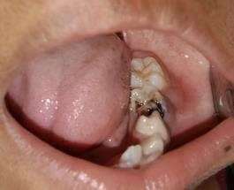
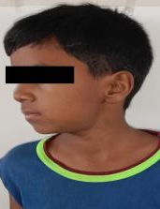
Figure 1 Intra oral findings (obliteration of buccal vestibule)

Figure 2 extra oral findings (swelling on lowe left mandible region)

Intra oral radiograph irw 75 shows radiolucency involving pulp .Occlusal view of mandible shows a large unilocular ,well circumscribed radiolucency below primary 2nd molar and enveloping the unerupted mandibular 2nd premolar and same finding may be seen in panoramic radiograph.[fig:3][fig:4] Cone-beam CT examination showed a rounded radiolucent unilocular lesion below the mandibular left primary second molar displacing the permanent second premolar successor to the lower border of mandible and a cortical expansion.[fig:5] Initially, a needle biopsy was taken from the lesion and the result of aspiration was a light-yellow odourless liquid that was immediately sent to lab for cytopathologic evaluation. The results approved the cystic nature of the lesion.

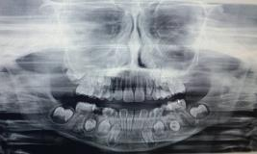
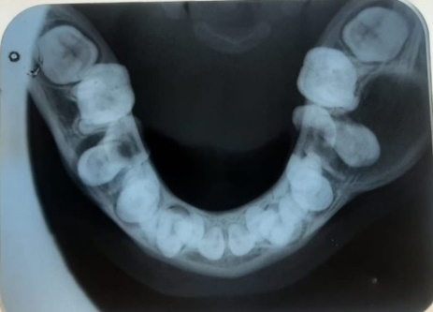
Figure 4: OPG
Figure 3 : Occlusal view

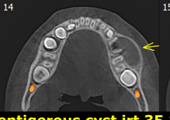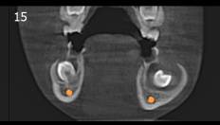
Figure 5 : CBCT findings

Treatment plan included extraction of mandibular primary second molar followed by marsupialization of lesion. Consent form was signed by the patient’s parents and the patient was scheduled for the surgery. At the day of surgery, standard disinfection protocols were followed and the area was anesthetized by block and infiltration injection of Lidocaine HCl with 1:80000 epinephrine. The affected teeth was extracted and cystic lining was scraped out with caution that no harm should be made to permanent successor and then lesion was irrigated with betadine and normal saline. Suture was placed to approximate the papilla and then cystic lesion was then packed with ribbon gauze dressing with Povidone iodine. Patient was kept on weekly follow up and on every follow up lesion was irrigated and ribbon gauze dressing was changed.
Histopathological report of cystic lining specimen shows proliferating thin non-keratinized stratified squamous epithelial lining with arcading pattern and underlying connective tissue shows severe diffuse chronic inflammatory cell infiltration, numerous capillaries, extravasated RBCs and focal area of haemorrhage was evident. All these findings confirm diagnosis of Radicular cyst. Duration of follow up increased up to 15 days as lesion started to heal with new bone formation. On 4 months follow up lesion was completely filled up with new bone and position of 2nd premolar was also changed and it has reached in socket. [fig:6][fig:7]Periodical follow-up is still ongoing.

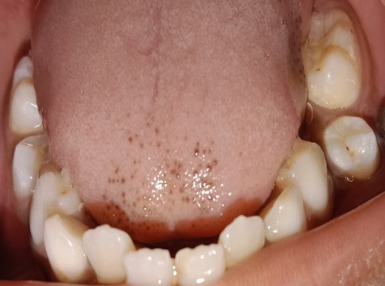
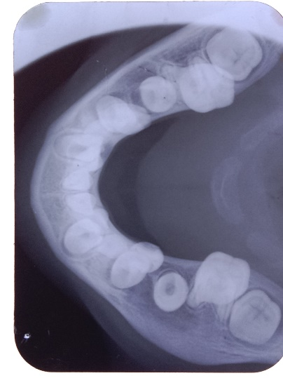
Figure 7 : 4 months follow up occlusal view showing new bone formation .

Figure 6 : 4 months follow up : clinically erupting 2nd premolar on its position

DISCUSSION:
Radicular cyst in primary teeth is rare. Low incidences could be because primary teeth are present in the jaw for short period. Moreover, pulpal and radicular infections in primary teeth tend to drain through sinus tract or the marginal gingiva, thus causing less severe symptoms, which may remain untreated.^{[6].} Mandibular molars are the favourable site for the development of radicular cyst as they are frequently affected by caries. Also, Cortical bone in this region is thick; therefore, lesion may not drain readily through sinus tract.^{[7]} On the other hand, in the permanent dentition, the teeth most affected are the incisors ^{[4].}
Radicular cyst associated with primary molar can be mistaken for dentigerous cyst arising from permanent successor. Differential diagnosis is vital to avoid extraction of permanent successor. Comprehensive assessment of clinical, radiographic, and histopathology examination and surgical findings can aid in this process. In case of radicular cyst, complete enucleation of the cyst and preservation of permanent successor is a suitable treatment option also Children have higher tendency for bone regeneration and faster healing of osseous defects, which was evident in our case also.
Marsupialization of the cystic lesion and using an appliance with projection for decompressing the lesion is another treatment option. Postoperative care is more demanding. Patient and parent cooperation are needed for success.^{[8]} In adults, following marsupialization, the time required for radicular cyst to reduce to their half size is approximately 6 months (Kubota Y et al. 2013).
Spontaneous alignments of the permanent teeth are likely even if their initial positions are not favorable.^{[6]} The present case showed good amount of bone formation and considerable alignment of displaced permanent teeth at 4-month follow-up.
CONCLUSION :
In conclusion, early treatment of carious teeth is recommended and also regular clinical and radiographic follow up for pulp treated primary teeth is strongly recommended. Early diagnosis and treatment of cystic lesion is also important to conserve permanent teeth.

REFERENCES:
- Sevekar S, Subhadra H N, Das V. Radicular cyst associated with primary molar: Surgical intervention and space management. Indian J Dent Res 2018;29:836-9.
- Narsapur S, Chinnanavar S, Choudhari S (2012) Radicular cyst associated with primary molar: A report of a case with an unusual radiographic presentation. Indian Journal of Dental Research 23: 550-553.
- Toomarian L, Moshref M, Mirkarimi M, Lotfi A, Beheshti M. Radicular cyst associated with a primary first molar: A case report. J Dent 2011;8:213-17
- Gandhi S, Franklin DL (2008) Presentation of a radicular cyst associated with a primary molar. Eur Arch Paediatr Dent 9: 56-59.
- Takiguchi M, Fujiwara T, Sobue S, Ooshima T. Radicular cyst associated with a primary molar following pulp therapy: A case report. Int J Paediatr Dent 2001;11:452-5.
- Mass E, Kaplan I, Hirshberg A. A clinical and histopathological study of radicular cysts associated with primary molars. J Oral Pathol Med 1995;24:458-61
- Grundy GE, Adkins KF, Savage NW. Cysts associated with deciduous molars following pulp therapy. Aust Dent J 1984;29:249-56.
- Ramakrishna Y, Verma D. Radicular cyst associated with a deciduous molar: A case report with unusual clinical presentation. J Indian Soc Pedod Prev Dent 2006;24:158-60.

